**Basic Calculator and Discount Calculator**

**Objective**:

The objective of this code is to generate a code for creating a graphical user interface application using tkinter in Python. It includes a basic calculator to perform arithmetic calculations. The second calculator is the discount calculator to calculate the final price after the discount.

**Benefits**:

The benefits of the user that can easy and more accurate to compute with the calculator.

Simple interface: Easy to use interface for calculation.

Time-saving: Calculation is done within few seconds.

Toolkit for beginners: It can be used to understand the GUI toolkit for beginner level students.

**Purpose**: The reason for this code is that the GUI application uses the tkinter library and its code written in this markdown file.

Purpose The code is aimed to outline a tkinter-based GUI application. It allows implementing the solution that creates multiple windows or Toplevel. The user is enabled to carry out basic arithmetic operations and get a discount based on the provided data. * Significance The code is also valuable since it demonstrates how the GUI is programmed in Python via the tkinter library. It can be used as a basis for more complicated solutions. For developers, it can serve as the starting point for designing applications with the same idea.

**Significance**: This code is significant as it is used as a GUI and takes an input integer and string and displays as it is a string specifies the functionality of tkinter and the output cost is a string means it can not perform the inline addition operation on integer.

**Features**:

Basic calculator: includes four function – plus, minus, multiply, and divide;

Clear function. The function that allows the user to clear the field in the calculator. It clears the field and resets the value of a or b in python;

Error calculation. If user put error function writhed error. In the future, it is possible to implement a function that does not receive error-alert messages;

Discount: discount . Calculates and outputs the discounted from the main price.

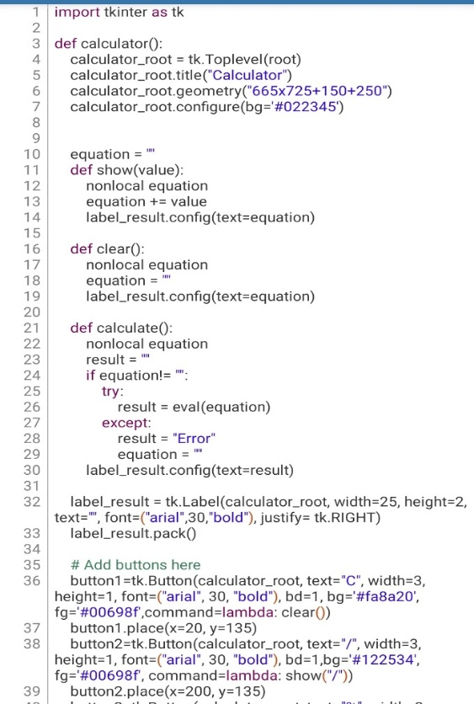**Code:**

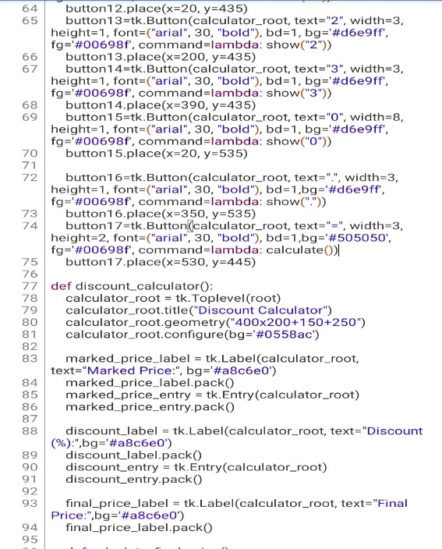

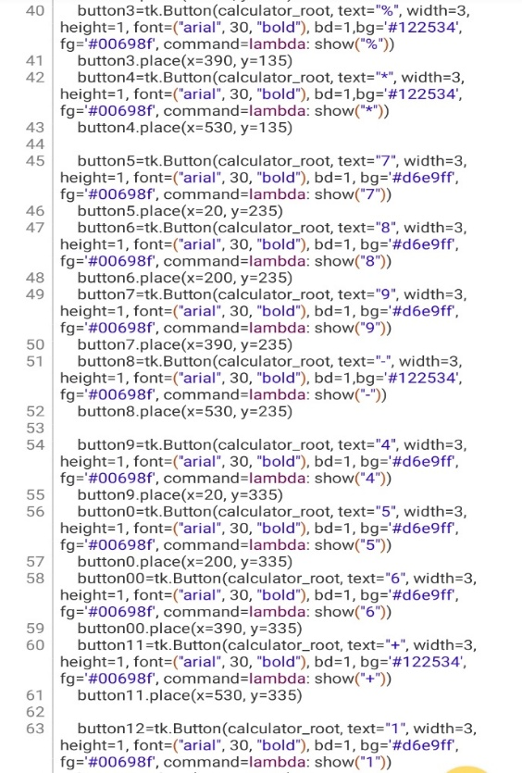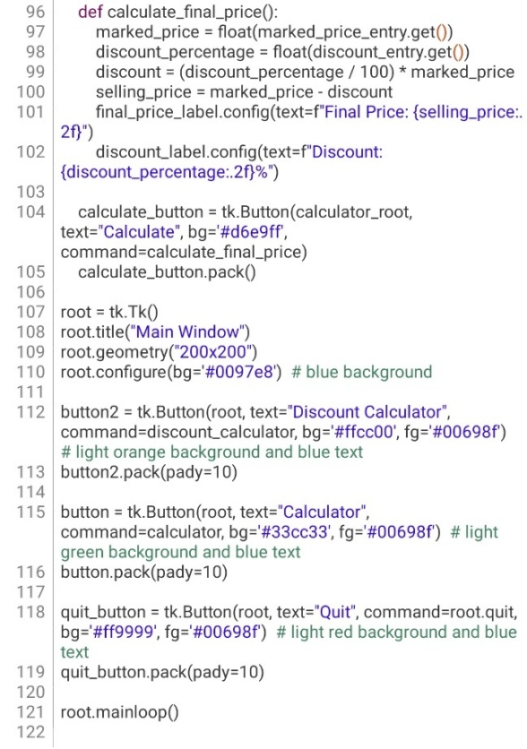

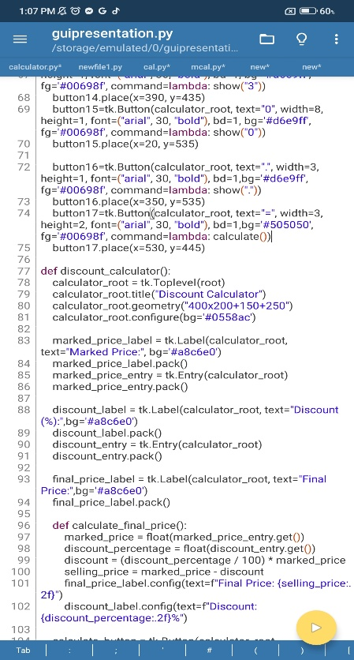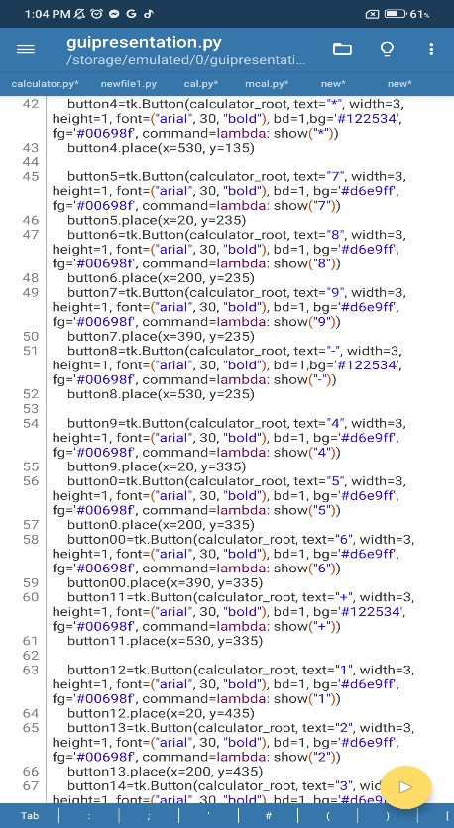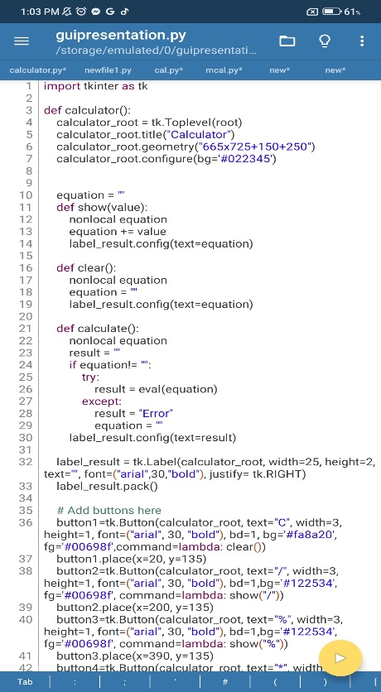**Screenshots:**

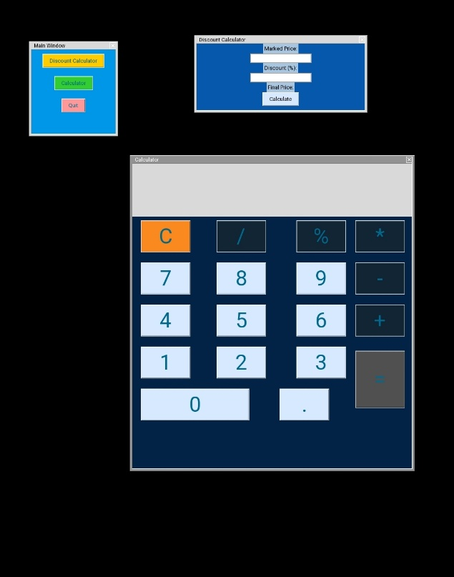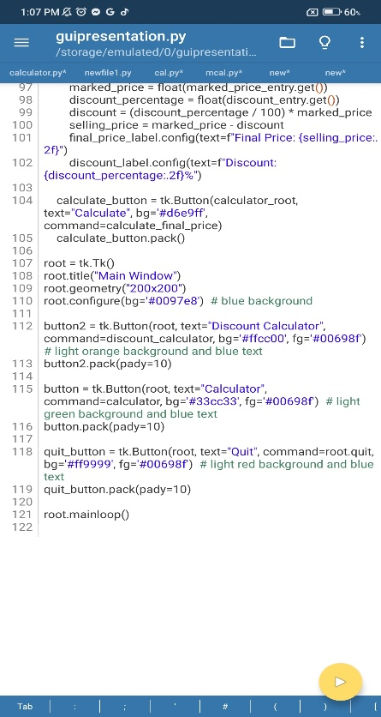



**PERSONAL INFORMATION**

Name: Kim C. Catay

Contact Number: 09108360435

Email address: kimcatay123@gmail.com

Date of Birth: 01/23/2004

Place of Birth: Surigao City

Address: Brgy, Canlanipa Surigao City

Age: 20

Nationality: Filipino

Religion: Roman Catholic

Civil Status: Single

**EDUCATIONAL BACKGROUND**

Elementary: Canlanipa Central Elementary School

Brgy, Canlanipa Surigao City

Junior High School: Taft National High School

Brgy, Taft Surigao City

Senior High School:Taft National High School

Brgy, Taft Surigao City